Ideation Phase

Brainstorm & Idea Prioritization Template

|  |  |
| --- | --- |
| Date | 19 September 2022 |
| Team ID | PNT2022TMID50661 |
| Project Name | A Novel Method for Handwritten Digit Recognition System |
| Maximum Marks | 4 Marks |

**Step-1: Team Gathering, Collaboration and Select the Problem Statement**

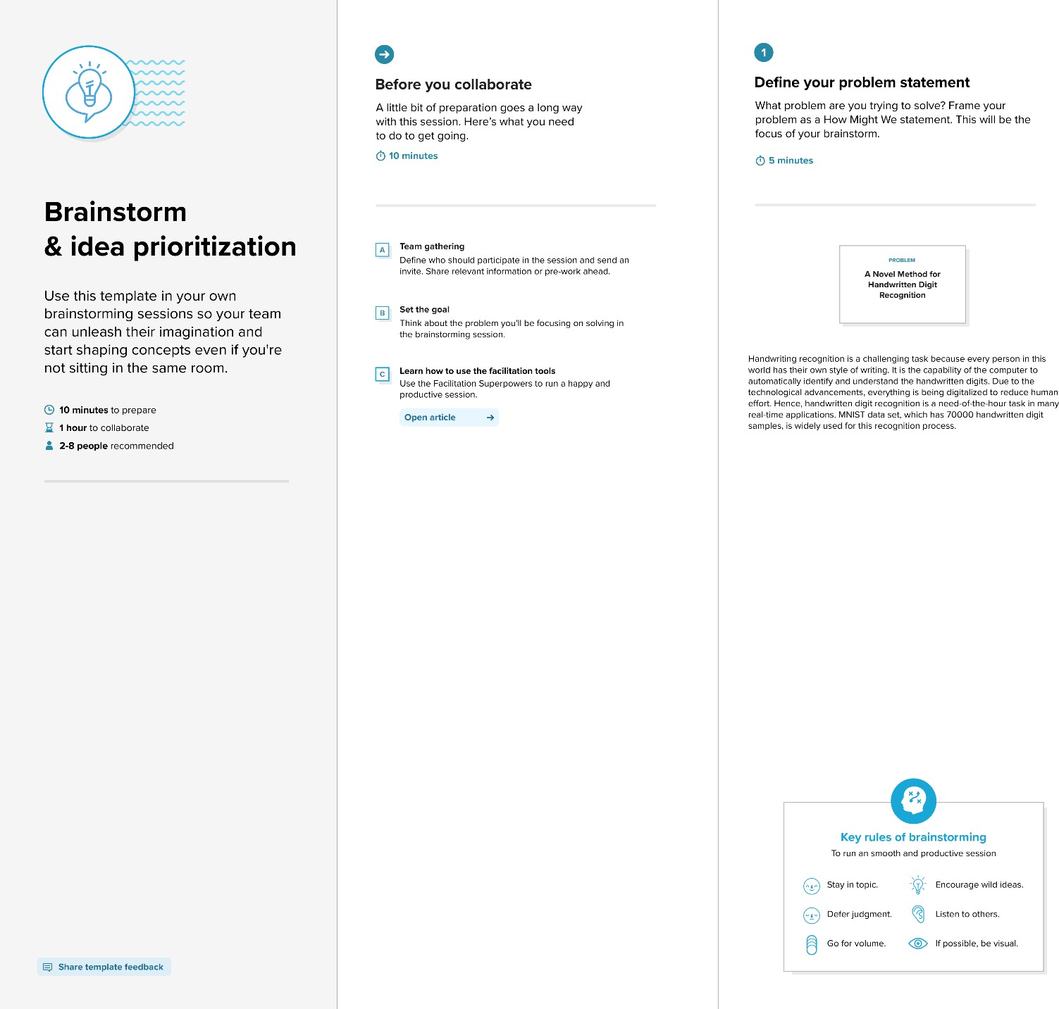

Step-2: Brainstorm, Idea Listing and Grouping

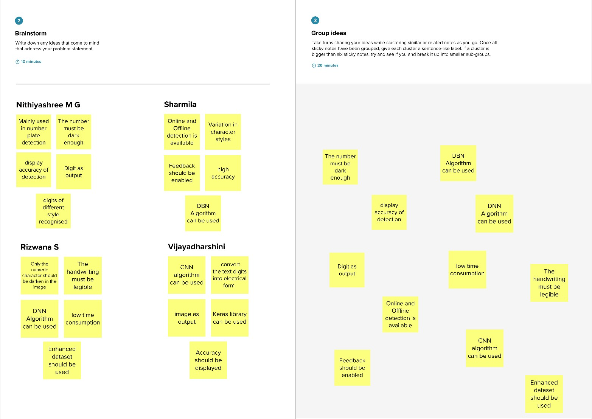

Step-3: Idea Prioritization

